**SCOSAAR**

**George Călinescu Institute of Literary History and Theory**

**Ph.D. field:** **Philology**

**Ph.D. coordinator: Acad. Eugen Ioan Simion**

**Ph.D. student** **(Surname and Name): ANDREI (STAN) P.PETRUŢA**

**SCIENTIFIC ACTIVITY OF THE Ph.D. STUDENT**

**(period 2016-2020)**

**- „Jurnalul literar” – study published in the magazine LITERE of the Târgovişteni Writers' Society No. 4 (205), April 2017;**

**- „Miron Radu Paraschivescu şi vocaţia lucidităţii” – study published in the magazine LITERE of the Târgovişteni Writers' Society No. 10 (223), October 2018;**

**- „Cronica unei eternităţi anunţate” – article published in the newspaper Vălenii de Munte, October 2019;**

**- „Jocul de-a iubirea” – study (chapter of the doctoral thesis) published in the Almanac "Amurg sentimental " - Bucharest, December 2020;**

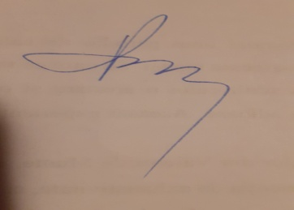



**Date: 09.04.2021**

**Ph.D. coordinator,**

**Acad. ...................................**

(signature)